COVID -19
ADDITIONAL INFECTION CONTROL MEASURES NECESSARY FOR PEOPLE WHO HAVE A PROFOUND AND MULTIPLE LEARNING DISABILITY (PMLD) AND OTHER HIGHLY VULNERABLE GROUPS

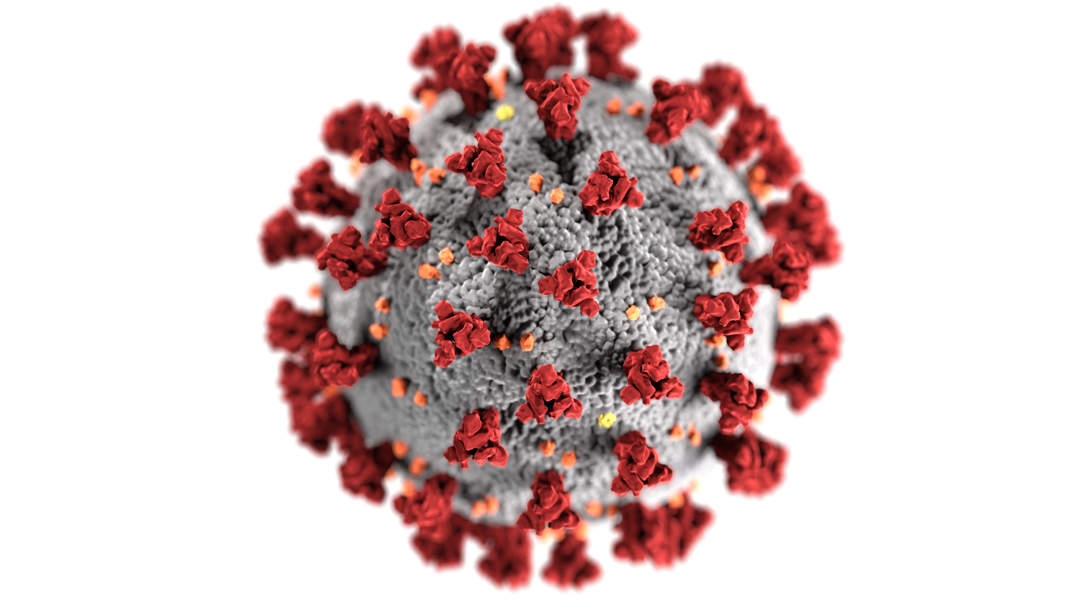

PAMIS INFORMATION AND RECOMMENDED
COVID-19 RISK ASSESSMENT DOCUMENTATION

Importantly, all up to date general government advice regarding COVID-19 measures should also be in place

Background Information
COVID-19 lockdown has impacted on us all. However, people who have been considered as requiring shielding are some of the most vulnerable due to ongoing health conditions. People who have profound and multiple learning disabilities (PMLD) and exceptional and complex healthcare needs are some of the most vulnerable of this high-risk group. Having said this, family carers supporting their son or daughter with PMLD especially those who have such additional healthcare needs have always had to be vigilant due to their relative’s vulnerability regardless of the existence of COVID-19. Family carers known to PAMIS are experienced in carrying out risk assessments daily, to protect their sons and daughters. However, the added risks associated with COVID-19 means that a more measured approach, as to how people with PMLD can come out of lockdown and participate in their local communities needs to be considered.
Are people this vulnerable not better kept isolated?
Lockdown has impacted on people with profound and multiple learning disabilities and their family carers greatly. Lockdown for the general population began on March 23rd 2020. Families caring for a person with PMLD recognised the dangers of remaining in close contact with their communities prior to this date and had to initiate their own lockdown early. People with PMLD have assessed high packages of care that requires help from various organisations, statutory services and or employment of personal assistants. Due to strict lockdown measures, educational settings, day centres, short breaks/respite and other suitable care provision have been unavailable. Many personal assistants, working and supporting care within the family home setting, have been furloughed and or redeployed. Many family carers have been left to care on their own with many unpaid family carers finding themselves isolated for months with many receiving no outside assistance. Family carer health and ability to continue to care long term has undoubtable been impacted negatively and many family carers have been at breaking point for some time.
People with PMLD have specific needs that require specialised help, have little or no verbal communication and they do not make sense of their world in conventional ways. They often have little understanding of change and the need for change. As a result, many have and continue to experience stress associated with their situation that directly affects their mental wellbeing. Lack of help and isolation from normal daily life continues to compromise this group of people significantly. The need to emerge from lockdown for everyone, regardless of ability or disability, is critical on many levels. People with profound and multiple learning disabilities and their family carers must also access normality albeit in a different form from before.

PAMIS Expert Reference group
Family carers are familiar with their own situation and know how to care and protect their child/young adult best. Family carers who are living the experience of lockdown whilst caring for a relative with PMLD and those whose son or daughter are in supported accommodation or similar facilities, and being shielded, are key to getting the shift from isolation to community involvement. To address the complexities involved, an expert family carer group convened.

The group’s priorities:

- use a solution focus approach to identify the steps necessary to deliver a safe pathway for people with PMLD that would allow them to access their communities as safely as possible
- stop continued isolation of people PMLD and their family carers who have been in isolation for months
- promote and improve physical, mental and emotional health for people with PMLD and that of their family carers.

The following was considered:

- what should coming out of lockdown look like for this group of people and what will be required to make it safe?
- do we need to establish an appropriate infection control regime?
- what spaces and areas in the community would be safe or safer?
- what already exists and what could be developed further?
- involvement of professionals who can influence change and those in a position to enforce necessary adaptations.

A number of meetings were held with the expert family carer group and some of the concerns and issues were shared with a wider group of interested professionals. All recognised the need to address the physical, mental and emotional health of people with PMLD and their family carers.

It was agreed that this COVID-19 information pack should be developed and shared with professionals across all disciplines who may deliver activities or provide support for people with PMLD during this challenging time. The need for vigilance if or when a vaccine is developed will still be necessary to instil family confidence. This may be the case for some time until anxiety levels and community evidence is available to confirm additional COVID-19 measures are no longer necessary.
Importantly, all government advice regarding COVID-19 measures should be in place as normal. Additionally, when engaging or carrying out activities that will involve people with profound and multiple learning disabilities the following extra measures should be actioned whenever possible.
Places and spaces:
- any indoor space or place should have, where possible, improved ventilation
- easy to find information regarding practices and measures taken especially around infection control and what to expect on arrival, should be accessible E.G website, FB pages visibly displayed on premises here facility equipment has been used this should be disinfected between uses.
- wheelchairs and other equipment must be wiped down if in contact with someone other than the person accompanying the disabled person e.g. wheelchair handles etc.
- information on availability of food and drink should be shared. This will allow family carers and paid carers to ensure they bring their own food and drink

Where a fully accessible changing places toilet is available, staff must be aware of the steps necessary to ensure safe practice.
- again infection control is crucial with suitable cleaning products available
- whenever possible, highly perfumed of chemically based products should be avoided
- if no automated ventilation system is in place (please leave door open between use)
- evidence that there are adequate monitoring and cleaning of CP toilets between use should be actioned
- monitoring access and use of CP Toilets (consider designated point for pickup of toilet key).

Important: People with PMLD will have a carer with them. If in doubt or there are concerns about any aspect of interaction with the person please ask the person accompanying for advice or assistance.

 |  | Number of people involved min/max:
Event/Activity: |  | Location of Activity:
Name: |  | Date completed:
Local COVID-19 Level  Verification process | 0 1 2 3 4 | Completion of additional PAMIS COVID-19 measures check list | Name:  Signature
Indoor /outdoor event
PAMIS staff member and or venue staff please carry out the following in addition to any existing COVID-19 measures in place as stated by government guidelines. Every effort to ensure as many of the following are in place should be made. However where issues arise, please document in comments.

Hazard  Ref. | Risk | Who is at risk? | Risk likelihood  Low/medium/  high | Risk severity  Low/medium/  high | Measures required to control the risk

PAMIS COVID-19 additional requirements | Check-list | Comments
Read PAMIS background information as part of this pack
Information and additional COVID - 19 expectations of participants displayed
Improved ventilation of indoor places and spaces
Information regarding accessibility shared publicly on venue website/FB page etc.
Availability of food and drink to purchase? Again on website etc.
Odourless products used (e.g. Dew products or similar) Dew products are recommended as they are backed by extensive research https://www.dewproducts.co.uk/
Availability of non-touch hand sanitiser where appropriate.

PAMIS staff member and or venue staff please carry out the following in addition to any existing COVID-19 measures in place as stated by government guidelines. Every effort to ensure as many of the following are in place should be made. However where issues arise, please document in comments.

NB: The above risk assessment and check list is in addition to any normal COVID-19 measures as stated by updated
Scottish Government guidelines.

Fully Accessible Changing Places Toilet
Additional considerations

Monitor access and use with cleaning between each use.
Consider designated point for pick-up of key and or clearly visible contact number to alert staff after use.

Consider installation of non-touch hand cleansing equipment
Suitable cleaning products used to disinfect after each use. (not highly scented) e.g. Dew Products or similar. Consider availability of dew air clearer spray for use between each use.

Increased ventilation If no automated ventilation system please leave door open between uses but only if changing places toilet is protected from inappropriate use. Use a suitable cleaning product if reduced air ventilation

Clearly visible instructions to encourage users to disinfect after use with appropriate cleaning products made available. E. G. Dew Products air cleaner spray or equivalent non- highly perfumed spray. Frequent staff overview of cleaning process. Clearly visible contact number to alert staff of use.

(Laminate cards etc.)

NB: The above risk assessment and check list is in addition to any normal COVID-19 measures as stated by updated
Scottish Government guidelines.

For further information please contact Brenda Garrard b.garrard@dundee.ac.uk

