Multi-Sensory Storytelling Performance – Easy Read

These workshops will look at the story of Alice in Wonderland.

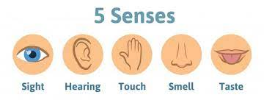

We will do this using our senses.

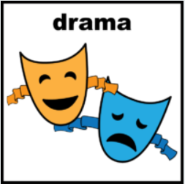

We will do this using drama.

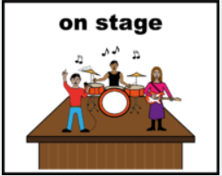

We will then work towards a performance on stage.

We will work with Paragon Music,

The ARC Castle Douglas and Dumfries.

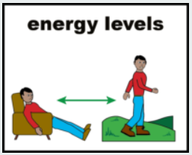
If you are part of these groups, make sure you can manage to do both without getting too tired.

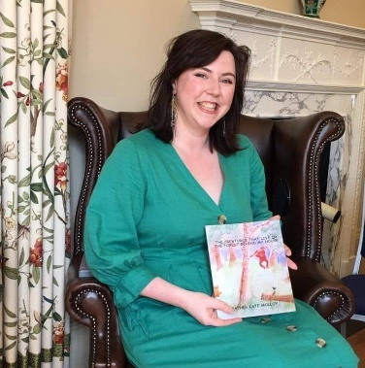

Heather Molloy will lead the workshops.

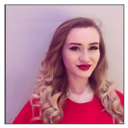

She will do this with Lucy McGill.

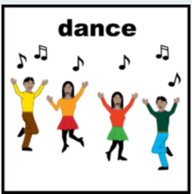
Lucy will do dance routines.

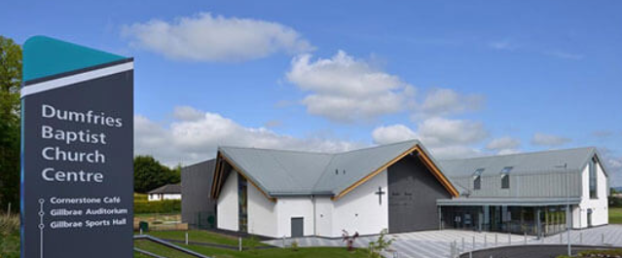
Workshops will take place at Dumfries Baptist Church

They will be on a Thursday Morning.

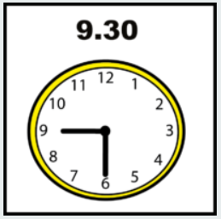

9.30am to 11.30am.

The performance will be at Dumfries Baptist Church.

There dress rehearsal and performance will be on Thursday 16th September.

From 10am until 3.30pm with breaks.

There are 10 places on these workshops.

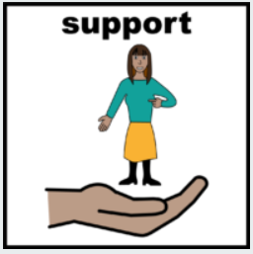

You can bring 1 person to support you.

Have a question?

Contact Heather at hmolloy001@dundee.ac.uk

To join, please complete the form below.

Need help?

Contact Heather at hmolloy001@dundee.ac.uk

Thank you

Registration Form
You will not be asked to disclose anything about a diagnosis of a learning disability or additional support need as part of this project. Any information requested is to ensure that individual sensory and communication needs are met.

Participant name:
Participant date of birth (must be 18+):
If you are coming up to 18 please contact us.
Contact name:
Contact relationship to you if not you:
Contact telephone number and email address:

Emergency contact name:
Emergency contact phone number:

Have you ever taken part in any storytelling, drama, or musical performances and/or workshops?
Yes ☐ No ☐
If you have never been to any of our workshops, we recommend attending at least the first few workshops with support. Will someone be accompanying you?
Yes ☐ No ☐

Sensory Needs:
In these workshops we will be exploring our senses. Do you have any allergies we need to be aware of?
Yes ☐ No ☐
If yes, what are you allergic to? ______________________________________________________________________________________________________________________________________

Are there any sensory dislikes or sensitivities we need to be aware of?
Yes ☐ No ☐
If yes, please tell us more about this here: ______________________________________________________________________________________________________________________________________
Do you have any visual or hearing impairments?
Yes ☐ No ☐
Visual ☐ Hearing ☐

Communication Needs:
Please tell us anything you think we need to know about your preferred communication.

Do you require an accessible car parking space at our venues?
Yes ☐ No ☐
Are you able to commit to workshops and rehearsals every Thursday from 9.30 – 11.30?
Yes ☐ No ☐
Are you available to attend the dress rehearsal and performance dates?
Yes ☐ No ☐
Thank you.

