*My story   
  
by Helen Johnston  
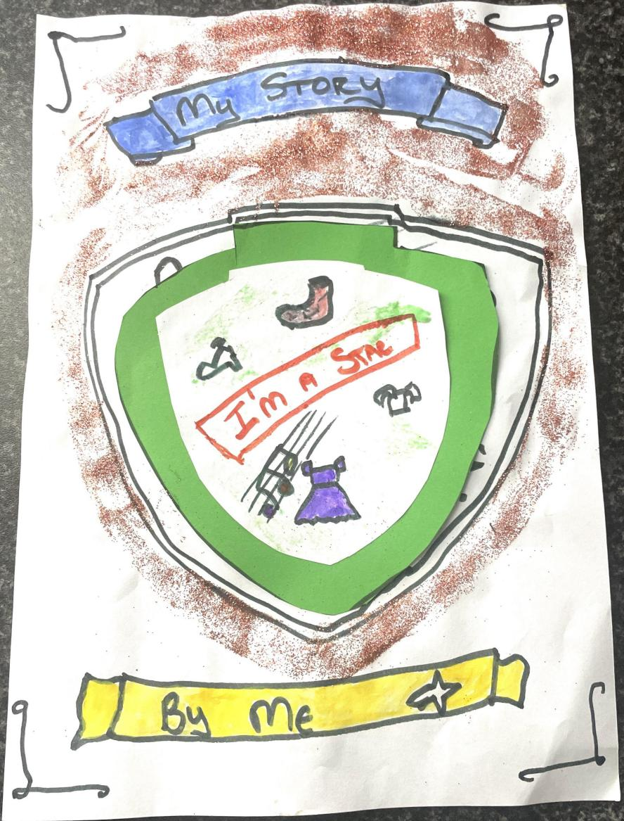  
This is my story and what makes me tick.  
I chose to make the front cover of my book like a shield that shows my strengths.  
I used watercolour painting, oil pastel and pen to make my book front cover and glitter to make it sparkle.  
I love going to shops buying clothes, shoes and listening to music.*

*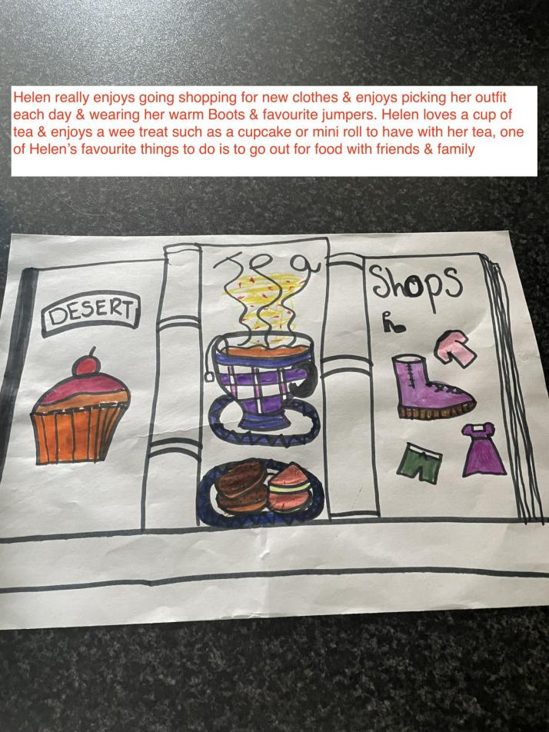*

*Three different things that make me happy.  
  
I thought of 3 different things that make me happy.  
Firstly I love scones and I wanted to do a picture of one as a book cover to see what it would look like.   
I also did a picture of a cup of tea with Jaffa cakes because I love these kinds of biscuits and tea.  
I then made a picture of shoes and clothes because I love going to shops, choosing clothes an shoes and wearing my favourite outfits.  
I made this painting with watercolour, oil pastel and colouring pencils and felt tip pens with assistance.*

*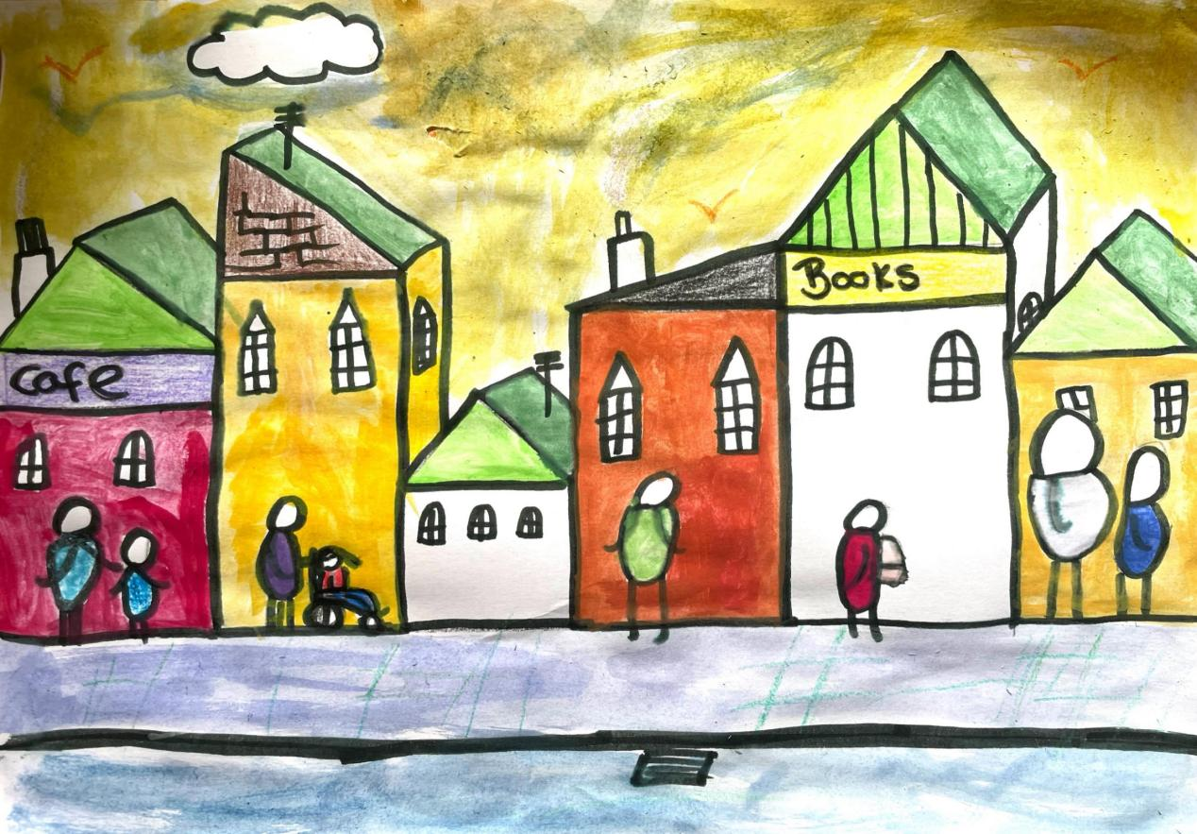*

*From an L.S. Lowry landscape-.  
  
My idea is about how much I enjoy shopping, and choosing things to buy, whether its shoes, clothes, food or stopping for a drink.  
In my painting I about queuing for the shops.  
Similar to the queue at the signing tent at the book Festival.  
The queue of people waiting to go into shops.  
I looked at an L.S. Lowry painting because he painted match stick people in Salford, Manchester where he lived and where CBeebies is broadcast.   
I love art myself, and making these illustrations to describe myself.*