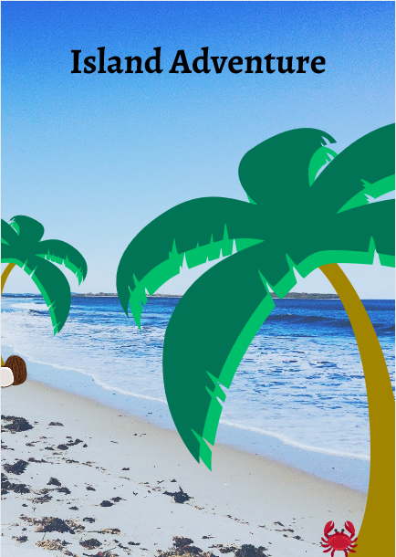

Interactive Drama Toolkit
Heather Kate Molloy for Pamis
The Scenes
Scene One
Sun, Sea and Sand

Scene Two
The Mysterious Rainbow Bird

Scene Three
Pirates!

Scene Four
Looking for Treasure

Scene Five
Food and Fire

Scene Six
Meeting the Natives
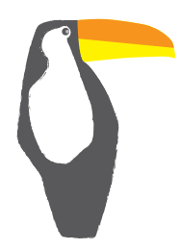
Start Routine
To be completed at the start of every new session or scene.
All participants to sit in two rows facing in the same direction.
Place sailor hats on (how to make instructions provided).
Music: ‘(What Shall We Do With The) Drunken Sailor – Port. Isaac’s Fisherman’s Friends.
Hold up the telescope (how to instructions provided) and look at the picture on Slide 2 of the accompanying presentation.
Anyone in the group can shout: ‘Land Ahoy!’

End Routine
To be completed at the end of every session.
CAPTAIN: It is the end of another busy day on the island. Time to relax.
Make is as dark as possible.
Cover each person with a blanket.
Music: https://www.youtube.com/watch?v=8myYyMg1fFE&t=6s
Listen for as long as you want.

SCENE ONE: Sun, Sea and Sand
The Story | You have discovered a new island whilst sailing. It is time to drop anchor and see what secrets this island holds. You start by discovering the weather, the land and the ocean.
Multi-Sensory Experiences | Sound – https://www.youtube.com/watch?v=DGIXT7ce3vQ  Or, if you have one, you can use an ocean drum. Instructions on how to make an ocean drum here:  Facebook: @fsharpmusicpractice  Sight – Slide 3,  Touch – sand (alternatively flour, salt), water, heat, rope, stick, towel  Smell – coconut oil  Proprioception – feet going into the sand  Vestibular – pulling  Taste – (Optional) Bounty Bar
Multi-media | Additional Music Suggestions:  ‘coconut’ Harry Nilsson  ‘Aloha Oe’ Elvis Presley  Donovan’s Reef movie soundtrack
Resources | PC or laptop, sand (or flour or salt), a tray or container to put the sand in, a container (big enough to fit feet) for water, coconut oil, sailor hat, rope, stick, tray, towel, hot water bottle, Bounty

- The first step ashore
Two people hold on to the end of the rope.
CAPTAIN: Heave! We have to get that boat onto the shore.
The two people with the rope gently pull whilst saying ‘Heave’
In a circle pass around the container with the sand. Feel the sand between fingers. If large enough it can also be used for the feet.
One at a time, take a handful of the sand and put it onto the tray. Once there is enough, take it in turns to write names into the sand. This can be done with a finger or the stick.

- Washing the sand off
FIRST MATE: This sand is getting everywhere! In my shirt and in my hair!
Make the water in the container lukewarm. Pass around and wash the sand away. Dry with a towel.
Optional: For extra fun you can add in inflatables, plastic fish or anything else you might have in the house.

- Relaxing under the warmth of the sun
CAPTAIN: Feel that lovely sun. We don’t get that in Scotland.
Look at slide 3.
Fill the hot water bottle with warm water (not too hot) pass around and try on different parts of the body to feel the warmth on that part of the body.
First Mate: Can you smell coconuts?
Pass around the coconut oil and smell.
(Optional) Taste a piece of a bounty bar.

SCENE TWO: The Mysterious Rainbow Bird
The Story | The sailors awaken on the beautiful island they discovered the day before. On waking, they hear an unusual animal call coming from the trees behind where they slept on the beach. They decide to go and investigate.
Multi-Sensory Experiences | Sound – Bird call  Sight – Slide 4  Touch – Feathers, Fur, Sequins (any other materials)  Vestibular - Movement
Multi-media | ‘The Lark Ascending’ Vaughan Williams  ‘The Birds’ Respighi  ‘The Birdie Song’ The Tweets
Resources | PC or laptop, empty toilet roll or kitchen roll tube, empty glass bottle, Plain paper, glue, coloured feathers, stickers, felt tips etc

- Finding the bird
Participants are in a large circle with enough space in the middle to crossover to another part of the circle.
CAPTAIN: Did you hear that?
Pass the tubes and glass bottles around and blow on to make an unusual sound.
CAPTAIN: It sounds like a bird. Let’s head into the trees and see if we can find it.
ALL: Aye Aye!
One person in the circle indicates another opposite them in the circle and moves towards them. Once they reach them, that person chooses someone and moves towards them and so on.
After a few turns add extra instructions:
- Move like you’re making your way through sticky mud
- Move like you’re on ice
- Move like you’re on hot lava
Look at the image on slide 4 and listen to one of the suggested pieces of music.
CAPTAIN: It’s beautiful. Feel how soft the feathers are
Stroke the feathers and use along the hands and face.

- Don’t forget the rainbow bird
SAILOR 1: I don’t want to forget that bird.
CAPTAIN: You’re right. Let’s recreate it and take it back with us.
Using the craft materials create the bird. If possible, use lots of different materials with different colours and textures. The group could create on large picture or each individual could design their own.

SCENE THREE: Pirates!
The Story | The sailors wake up to find they have been surrounded by dangerous pirates led by the dreaded Captain Danglybogey. The pirates believe the sailors are on the island to find their treasure and tie them all up. The sailor’s captain challenges Captain Danglybogey to a card game. If he wins the pirates leave and give the sailors the treasure map, but if they lose, the pirates can feed him to the crocodiles.
Multi-Sensory Experiences | Sound – clapped hands  Sight – Slide 5 & 6, playing cards, rope  Touch – rope, playing cards  Propprioception – rope tied around (legs or arms) this could just be held and not actually tied.  Smell – Rum/beer
Multi-media | Music Suggestions: https://www.youtube.com/watch?v=6zTc2hD2npA  https://www.youtube.com/watch?v=rNkL8cDhhb0&list=PLdoAHt8OS91DU4MzIPbNTKUrJhflwf6vI&index=7&t=0s  https://www.youtube.com/watch?v=cXSlkFRKas0&list=PLdoAHt8OS91DU4MzIPbNTKUrJhflwf6vI&index=7
Resources | PC or laptop, Playing cards (or pieces of paper with numbers 1 – 13), rope, beer/rum (alcohol smell)

- There’s nowhere to run!
CAPTAIN DANGLYBOGEY: Wake up maggots!
SAILOR 1: Oh no! We’re tied up.
CAPTAIN DANGLYBOGEY: You’re not getting your hands on our treasure.
Take it in turns to tie up the sailors. The rope can be wrapped around the legs, arms or waist. Gently rock to demonstrate trying to escape.
Do this whilst listening to one of the music suggestions and looking at slide 5.
One of the pirates comes and leans in the sailor’s faces. They can smell the rum on his foul breath.
Pass around the rum/beer bottle to smell.

- Captain’s Challenge
CAPTAIN: I challenge you to a game of cards.
CAPTAIN DANGLYBOGEY: Deal. If you lose, I will feed you to the crocodiles.
CAPTAIN: But if I win. You give us the treasure map and leave the island.
Take it in turns to turn over one of the cards. If the captain has the higher card then all celebrate and it is the end of the scene. If the captain loses look at slide 6 and clap hands to show the crocodile eating the Captain.
This scene can be replayed until the Captain wins. If there are other people taking part they can take a turn.

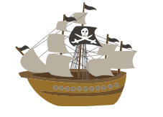

SCENE FOUR: Looking for Treasure
The Story | The sailors have Captain Danglybogey’s treasure map and set off to find the hidden treasure. After searching for some time, and following all of the clues, the sailors find a chest buried deep in the earth. They open it to find lots of beautiful jewellery which they share out amongst themselves.
Multi-Sensory Experiences | Sound – music chosen for the scene  Sight – Slide 7, treasure map, treasure chest, treasure  Touch – dirt, trowel, treasure map, treasure chest, treasure  Vestibular – Digging, Opening chest  Taste – Chocolate/sweets (optional)
Multi-media | Music Suggestions:  ‘Money, Money, Money’ Abba  ‘Money’ Pink Floyd  ‘No Money’ Galantis
Resources | PC or laptop, treasure map, container (treasure chest), treasure (e.g. jewellery, sweets), bucket, dirt, trowel*

* The bucket can be filled with dirt and the container buried inside or this could be done in separate parts with digging in the garden using a planter etc.

- Locating the treasure
Depending on how many people are participating, split into 2 groups.
Group 1: Take the treasure and hide it somewhere in the house/outside and draw a treasure map leading to it.
Group 2: Prepare for the journey whilst this is taking place by doing the following exercises.
- Take 3 deep breaths
- Roll/Wiggle shoulders.
- Shake hands
- Point toes and ankle circles
Group 2 can also take time to go and get the tools they need to dig the treasure chest (trowel).
Someone in Group 1 plays the part of the CAPTAIN in this scene.
CAPTAIN: Here is the treasure map. Let’s go get our hands on all those jewels.
Group 2 leads as they follow the treasure map and seek the buried treasure chest.
SAILOR: I think we’ve found it.
Take it in turns to use the trowel to dig the dirt and pull out the treasure chest.
Open the chest and examine the contents within one at a time.
(An example treasure map is available at the end of this booklet)
SCENE FIVE: Food and Fire
The Story | The sailors decide to build a great fire and have a feast to celebrate finding the buried treasure. They collect branches and other things to make the fire and then go in search of food. They find all kinds of different unique foods with lots of different colours and flavours. They then fall asleep by the fire.
Multi-Sensory Experiences | Sound – music chosen for the scene, snapping twigs, fire crackling  Sight – Slide 8, different foods of different colours and textures.  Touch – heat, sticks, food  Taste – spring onion, peppers, (all can be substituted for individual taste preferences – but this can be used to try new foods)
Multi-media | Music Suggestions:  Fire crackling - https://www.youtube.com/watch?v=UgHKb_7884o  ‘I See Fire’ – Ed Sheeren
Resources | PC or laptop, branches, twigs, foods, knife

- Building a fire
If you have access to a garden, this activity is fun to do outside. If not the activity can still take place indoors with sticks etc brought in or, for extra humour, anything wooden that can be burnt from inside the house.
CAPTAIN: Right! Time to celebrate. Let’s get a fire lit.
Collect as many different things as possible; branches, twigs, dry leaves. Once gathered, pass them around the circle one at a time and judging if they will be good to use on the fire.
For larger twigs snap them into smaller pieces and enjoy the sound and action.
In turns, put one on top of the other to build a bonfire.
CAPTAIN: Good work.
If you have access to a garden, and it is safe to do so, you could build and light the bonfire. If indoors, you could use a fire, central heating, hot water bottle, or hair dryer for warmth. Try to feel the heat from the fire on different areas of the face and body.
- Time for a feast
SAILOR: I’m hungry.
CAPTAIN: You deserve a feast.
- Using the knife, carefully slice the bottom and first 2 inches off the spring onion. Next, cut inch lengths into the top of the spring onion so it looks like a palm tree.
CAPTAIN: Look at this strange plant we found. It looks tasty.
Hand one to each participant. First, look at the colour, then the smell, and finally taste.
- Cut slices from different colour peppers.
CAPTAIN: These be slices from the rainbow fruit.
Pass the different slices around as before.
Experiment with as many other different foods as you’d like.
You could use cookie cutters and moulds to cut different shapes into fruits such as melon and pineapple and describe them as flavoursome flowers.
Once you have feasted;
CAPTAIN: We have one more day on this island before we set sail home. Time to get a good night sleep.
Take it in turns to yawn as loudly as you can.
Take it in turns to make the loudest snoring sounds.

SCENE SIX: Meeting the natives
The Story | It is the sailor’s last day on the island. They are gathering their belongings when a group of local islanders appear from the trees. Their leader speaks English but agrees to teach the sailors their native language.  One of the sailors does this and starts a conversation with a local girl and they fall in love.
Multi-Sensory Experiences | Sound – music chosen for the scene, clapping hands, clapping lap, vocalisations  Sight – Slide 9  Touch – wool  Smell - coffee  Vestibular – dancing/movement
Multi-media | Music Suggestions:  ‘Yeha Noha’ Sacred Spirit  ‘Puirt’ Manran
Resources | PC or laptop, paper and pen, wool, coffee

A > Ḧ

- Learning a new language
Someone in the groups make a loud wailing sound.
CAPTAIN: Quick. Wake up!
The Native’s Leader approaches. Pass around the wool to demonstrate his long beard. His breath smells of coffee. Pass around the coffee to smell.
NATIVE LEADER: Welcome Sailors. We have watched you. My people do not speak your language. This should help.
(Use the code on the next page to help in the next section.)
One at a time, use the code to translate your name into the native language.
Next, learn the word ‘Hello’ and do this all together to the person playing the Native Leader.
- Falling in love
NATIVE GIRL: (Use the code to say that she has fallen in love with one of the sailors)
Everyone in the circle makes a ‘awww’ sound.
SAILOR: I love you too.
Everyone in the group holds hands.
NATIVE LEADER: You are all welcome here anytime.

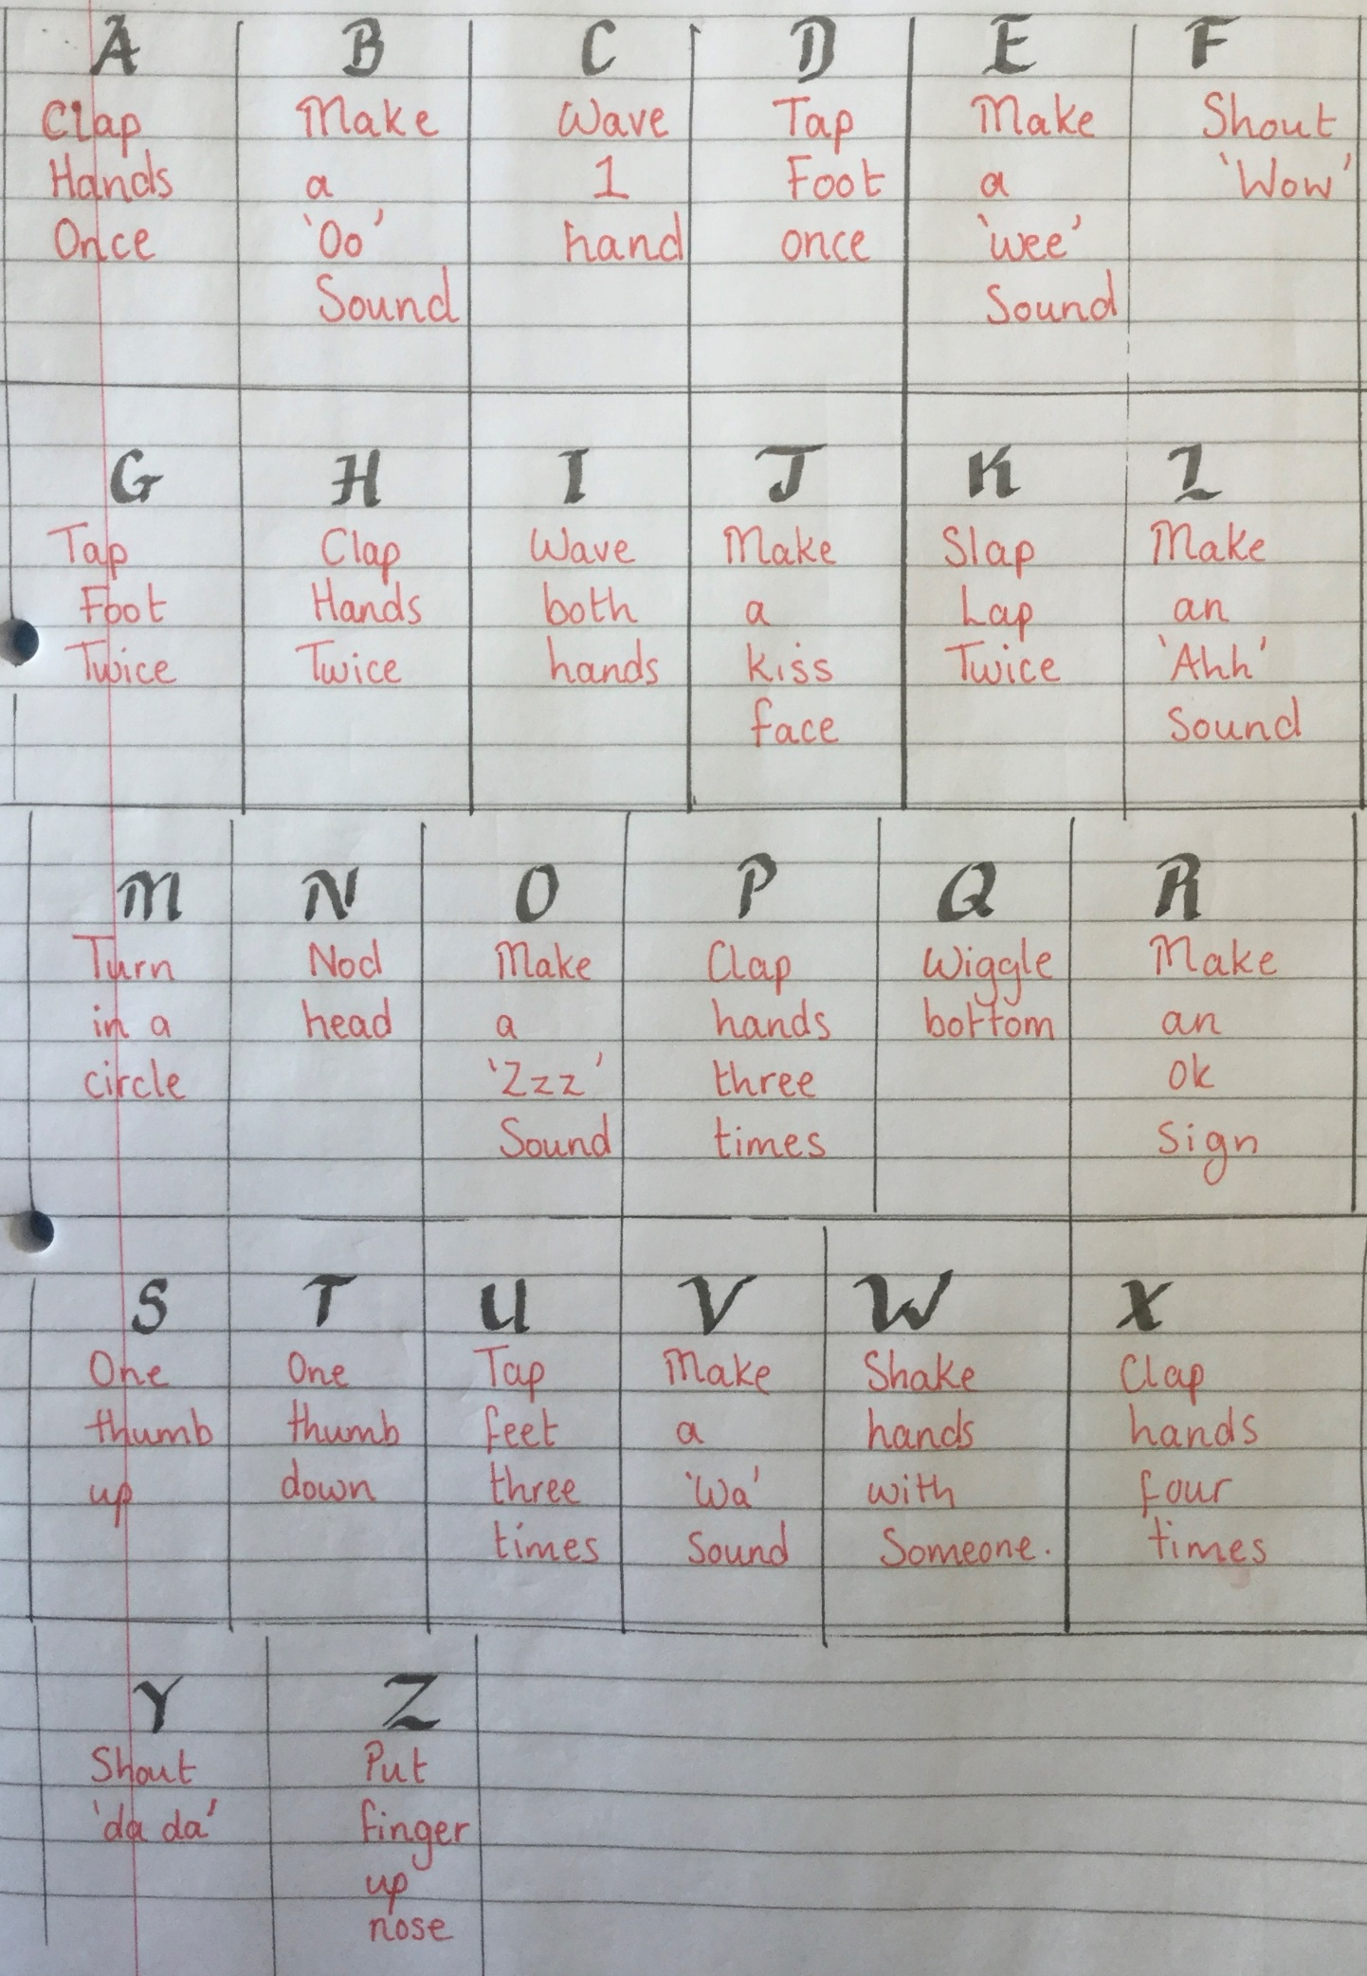

- Dance the night away
Play one of the music suggestions.
Stand in a circle as though there is a fire in the middle. Everyone put their hands in the middle as though they are feeling the warmth from the fire.
Dance to the music.
CAPTAIN: It’s time to set sail.
NATIVE LEADER: Goodbye.
SAILORS: (All say goodbye in the native language).

