PAMIS Volunteer Job Profile

1. Job Details
Job Reference | PAMIS/003
Job Title | Volunteer - Mobile Changing Places Toilet
Location | Beaches in Scotland throughout July,  Edinburgh Fringe Festival throughout August and many more events
Reporting to: | Chief Executive Officer

2. Mobile CP toilet and the Volunteer role

Thousands of people with complex needs across Scotland are unable to attend events or visit outdoor venues due to the lack of appropriate toilet facilities and to this end PAMIS have purchased the first Scottish fully accessible mobile changing places toilet. The ‘Mobiloo’ will be spending the whole of August at the Edinburgh Fringe, and volunteers are required to man it throughout the month. It will be permanently based at Windmill Street, George Square, within the University grounds and will be open from 10am to 10pm every day throughout the fringe. The shifts will be 4 hours each and there is likely to be 2 people working together on each shift.

It will be hired out for many other events, e.g. Pony Axe S on the following dates and beaches:
Monday 17th July – Troon; Wednesday 19th July – St Andrews; Friday 21st July - Portobello; Sunday 23rd July - Broughty Ferry; and Tuesday 25th July - Balmedie Beach “it takes people who use wheelchairs to all the places where wheelchairs can’t take them” https://ponyaxes.com/

Drivers have to be 25 years old and over, as stipulated by the insurance policy. You could volunteer to be a driver and drive it to different venues. All bookings will be arranged through PAMIS.

We also require volunteers to open and close the van, be an attendant and supervise the use of the mobile changing places toilet. Training will be given.

Note: a child or adult with profound and multiple learning disabilities (PMLD) will always be accompanied by at least one carer at all times

3. General Information about PAMIS
PAMIS is the only registered charity in Scotland working solely with people with profound and multiple learning disabilities (PMLD) and complex healthcare needs, and their family carers. It is acknowledged as a centre of excellence for research, education and service development in the area of PMLD both nationally and internationally. There are currently five offices across Scotland Dundee (Tayside), where the head office is based, South Lanarkshire, Fife, Greater Glasgow and Clyde and Grampian. However PAMIS provides advice and campaigns for the whole of Scotland and the educational resources are also shared nationally and internationally.

People with profound and multiple learning disabilities are a diverse group of individuals with their own personalities, preferences and ways of communicating. The abilities of those described as having PMLD vary considerably and not least because of the varied life experiences they may or may not have had. They are one of the most marginalised group of people in society. Due to the multiplicity of their disabilities they are often excluded from playing a full role in society, primarily because our communities are not inclusive, or not inclusive enough. Profound means deep, intense, wise, requiring great insight or knowledge and although many people with PMLD have significant areas of disability they also have unique areas that never cease to surprise those who care and work with them. People with PMLD will invariably be wheelchair users, have significant health problems and require 24/7 care.

4. Skills/knowledge/experience needed

Full, clean driving licence, if you wish to volunteer as a driver - 25year olds and over
Reliable and trustworthy
Willingness to meet and support a person with PMLD
Enthusiastic and friendly
PVG desirable (can be arranged through PAMIS)
You will be required to supply 2 referees

5. What we offer volunteers
Training: A full training session will be given to all volunteers wishing to help with the mobile changing places toilet. Volunteers can utilise the PAMIS learning and development educational hub which includes workshops and learning bytes on: communication; health and safety guidelines; sensory integration; inclusive activities; etc. It may be CPD accredited in the future.

Expenses: Reimbursement of agreed out of pocket expenses and travel.

Experience: hugely valuable and rewarding experience, the opportunity to learn new skills and to travel. Saltire Awards accreditation (12-25 years old)

Our thanks and appreciation.

For more information please contact Lesley Gray, l.u.gray@dundee.ac.uk or
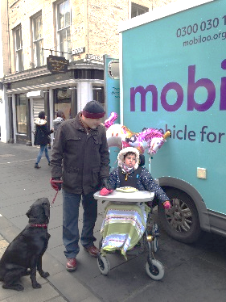
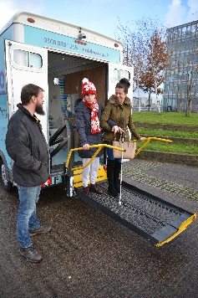
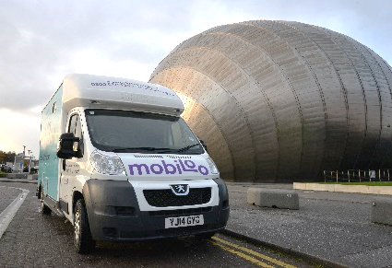
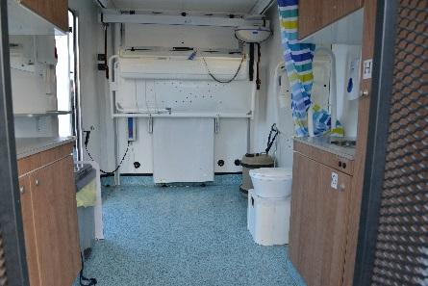
01382 385154. You can visit our website: www.pamis.org.uk

